Written Progress Report
Introduction and Project Overview:
Pokémon: Legends of Arceus takes place in what Pokémon calls the Sinnoh or Hisui region, which maps on to the real-world Japanese province of Hokkaido and coincides with the actual historical colonization of this region. Arceus, however, presents a whitewashed version of this history, one without indigenous people or colonization, where instead peaceful settlers from other regions arrive on an island inhabited only by Pokémon and pleasantly build villages while the player conducts research toward the creation of the region’s first Pokedex. I call upon Bogost’s procedural rhetoric, Trammell’s Decolonizing Play, and indigenous game studies, in addition to the concept of modern Japan’s soft power as presented through video games to question the rhetorical work of Arceus and the implications for colonized play evident in including revisionist history and indigenous erasure in the embodied processes of this franchise as manifested by player reviews of the game.
This project was started in Dr. Salter’s Fall 2022 Introduction to Text and Technologies course. In the original draft, a sample of both player and professional reviews penned in the English language were collected between November and December of 2022. Professional reviews from large-scale publications were collected from Metacritic’s aggregate critic score for the game and via Google Search. When referenced, professional reviews published in blogs or on critical websites will be referenced by the author and publication name. An additional sample of user reviews were collected from Metacritic. No private identifying information such as usernames from individual player reviews was stored in order to protect the anonymity of the users. To determine if the user and professional reviewers' discussions of indigenous representation were consistent with other online discourse regarding indigenous representation in the game, additional posts regarding indigenous representation in Arceus were datamined from Reddit and Twitter. The sample was then digitally scanned using the CTRL+F function to find three specific keywords within the text bodies of those reviews: indigenous, Ainu, and colony/colonization. Where these terms appeared, additional focus was given on the context of how these terms appeared in the review. Where they did not appear, it was instead noted that the review did not feature any of the searched terms.
While the theoretical background for this project is strong, feedback I have received on this project is that it needs more sophisticated methods in order to be a useful academic contribution. I would like the revitalize it, therefore, by electing the third option for the research project for DIG 6836 and instead use Python to scrape Metacritic and Reddit for the same terms in order to obtain a larger and more sophisticated sample of data to analyze.
Data Collection and Preprocessing:
As described in my initial proposal, I did use my classmate, Mirek’s, scraper to collect my initial dataset in a .csv, which presented a bit of a learning curve. I have completed my initial scrape and have data, however, I have found that two of my proposed keywords do not draw results on Reddit, wheres they have hits in the hand-scraped data from Metacritic taken in 2022. I recently learned that Mirek also has a tool for Metacritic, so I may attempt to see if I can repeat those results with that tool as well. I have yet to code my data of yet as I may be expanding my sample.

Analysis and Insights:
No real analysis yet given I’ve just gotten my first stab at some data this evening after doing battle with Mirek’s scraper all week, but I do think it’s curious that two of my intended keywords didn’t appear on Reddit. My thought is I may need to rethink my keywords as I might be trying to use too academic of language for Reddit.
Visualization:
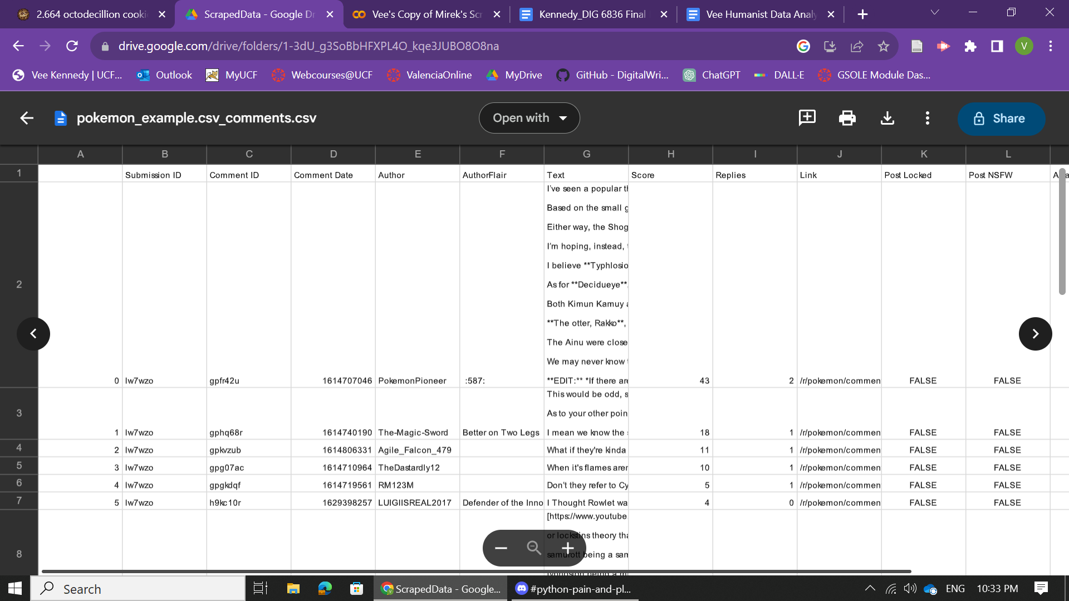
Nothing beautiful or fit for human consumption as of yet, but here is my glorious .CSV file from Mirek’s Scraper.
Challenges and Mitigations:
It took me a solid week to get the scraper to work specifically because I entered the wrong values in the client_secret and secret_id panels in the Colab file. I entered the actual values in a place where I just needed to type “client_secret” and “client_id” and kept getting an error that said “no such client_id exists,” which makes a lot more sense now.
Remaining Tasks:
My remaining tasks include re-evaluating the terms searched to see if I can draw up a better sample from Reddit, potentially employing the Metacritic Scraper tool, and then coding the data to determine if the results are similar to last year’s hand-scraped sample.

